**Laboratory One**



**Javier Jesús Macossay-Hernández**

**EE348L – Electronic Circuits**

**University of Southern California**

**Professor Susan Schober**

**Introduction**

In circuit design, specialized software is used as a tool to analyze and design circuits. These softwares are helpful when designing extensive circuits that will required significant amount of time to analyze. HSpice, which is distributed by Synopsis, is the circuit design software that will be used in class. The purpose of this laboratory is to help the students explore and get familiar with HSpice. In addition, circuits will be analyzed by hand and software simulations. Furthermore, hand and simulation results will be compared. The differences in results between the two different methods are being investigated in this laboratory.

Exercise 1

**Procedure**

On Exercise 1, node analysis was done to get the voltages of all the nodes. Eventually, the currents were calculated by getting the voltage drop across the resistors (R3, R4, and R5) and implementing Ohm’s Law, as shown in hand calculations. In addition, HSpice was used to confirm these hand calculations.

**Data**

The following images are screenshots from the HSpice output file.

This image contains the voltage values at each node.

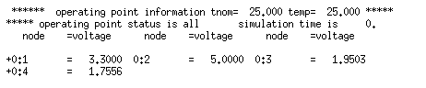

This images contains the currents through resistors.

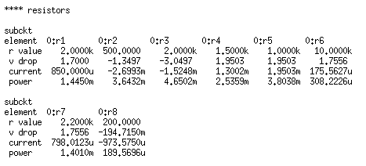

**Questions**

No questions were asked in this exercise.

**Discussion**

The results form the HSpice simulation match with the hand calculations. Therefore, the hand calculations were done correctly. The results help me to realize that node analysis is a reliable procedure to find the node voltages. The voltage in node one is 3.3 V, node two is 5 V, node three is 1.95 V, and node four is 1.755 V. The currents through resistor R3 is 1.52 mA, R4 is 1.3 mA, and R5 is 1.95 mA.

Exercise 2

**Procedure**

On Exercise 2, finding transfer functions, ideal gain, and doing some analysis in the transfer function were required to do by hand calculations. In addition, we were asked to verify our answers with HSpice simulations and WaveView Analyzer

**Data**

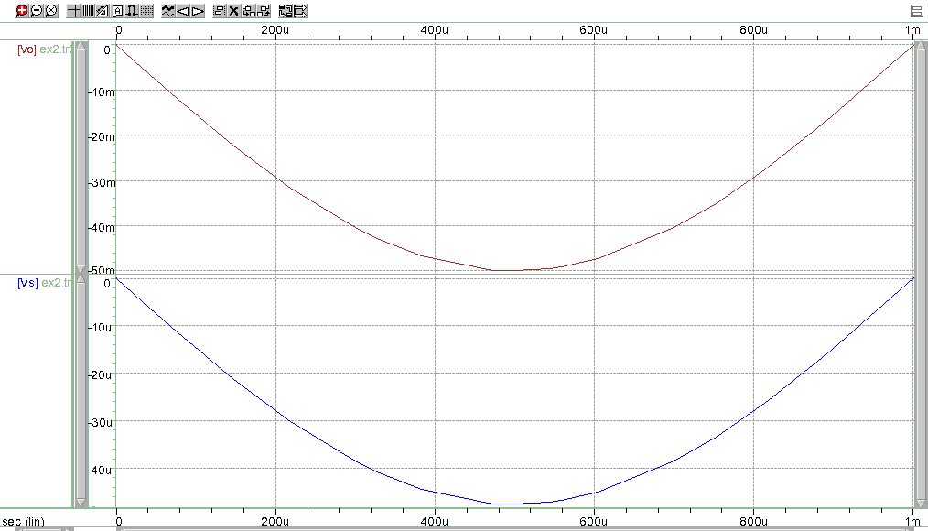

Ao = Ai

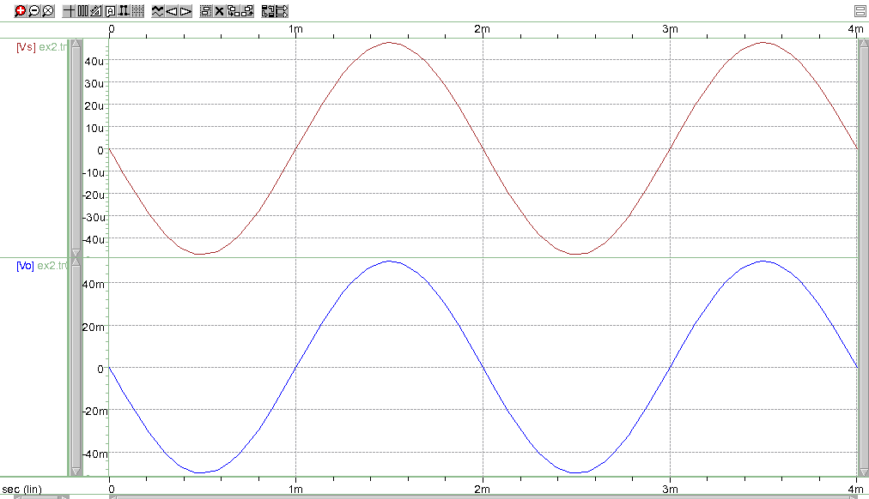

Ao = 10Ai

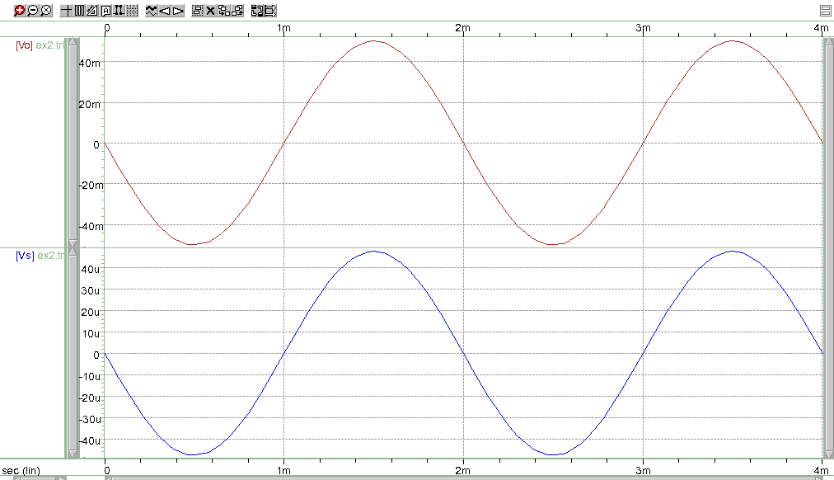

Ao = 100Ai

**Questions**

The tstep we need to use if we want to plot 1000 points/period is 2 μs and the tstop to plot 2 perios is 4 ms

**Discussion**

The output signal was amplified according to the factor of the gain, corroborating hand calculations.

Exercise 3

**Procedure.**

On Exercise 3, HSpice simulations were used to construct the RC circuit desired using a 2 kΩ and .1 μF. In addition, WaveView Analyzer was used to analyze the results. The voltage source used is a pulse generating source that alters between 0 V and 5 V. The source had 1 ms delay, 5 ms pulse width, 10 ms period, and a rise and fall time of 1 ps.

**Data**

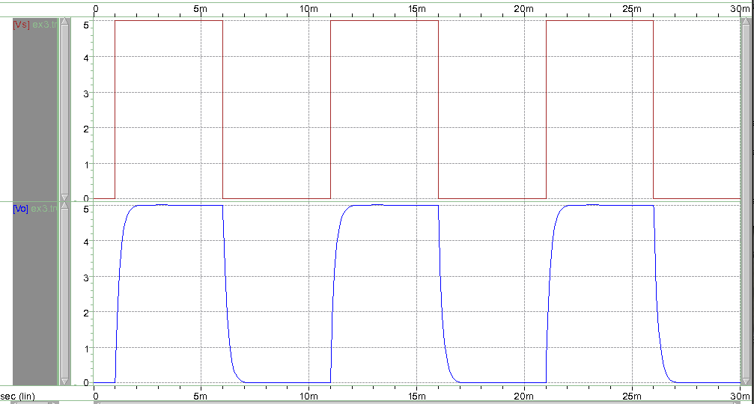

Transient Simulation Time: 30 ms

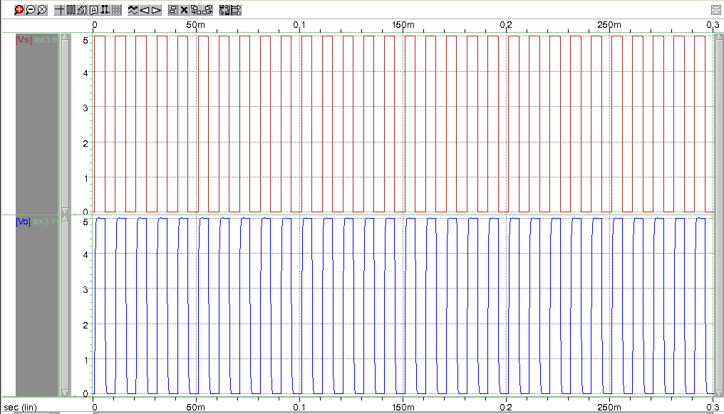

Transient Simulation Time: 300 ms

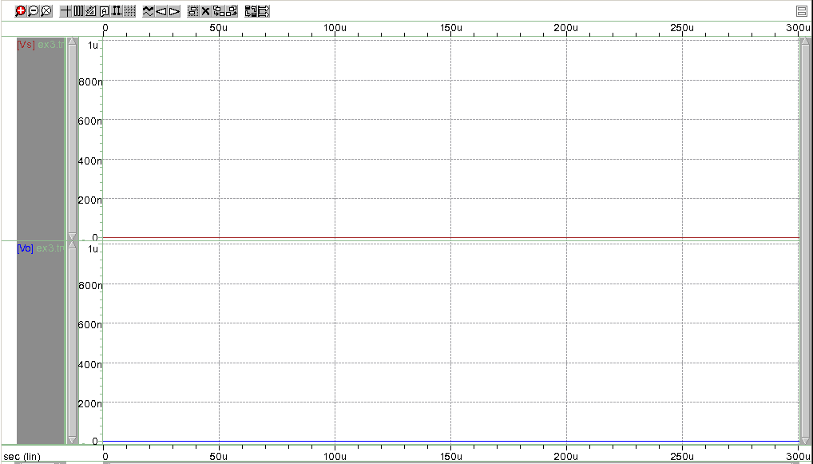

Transient Simulation Time: 0.3 ms

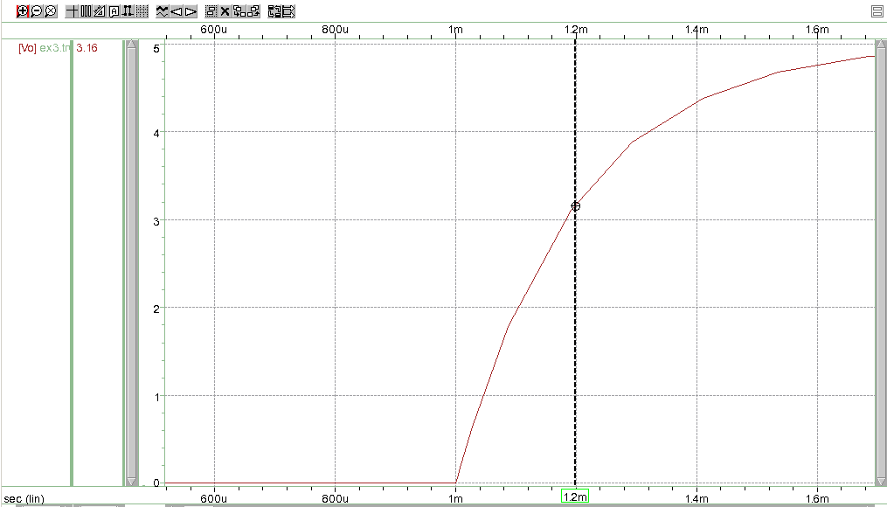

The graph shows the time constant 0.2 ms at 3.16 V

**Questions**

The results differ when using three different simulation times. If an educated decision when choosing a simulation time for the simulation is not done properly, then the resulting graphs on the output will not show the needed data to interpret the results. If 30 ms are used for the simulation, then we will have the desired graphs that correspond to the response of the RC circuit. When 300 ms were used, the graph was highly populated by the response of the circuit, therefore the results were difficult to analyze. In contrast, if 0.3 ms are being used, the resulting graph will not show the response of the RC circuit because not enough time was given to the circuit.

In addition, the time constant of this circuit is 0.2 ms and the 63% of its final value is 3.16 V. This value was verified with HSpice and the results matched with the hand calculations.

**Discussion**

The results form the HSpice simulation match with the hand calculations. Therefore, the hand calculations were done correctly. The time constant is 0.2 ms and the value of the capacitor at that time is 3.16 V.

Exercise 4

**Procedure**

On Exercise 4, HSpice simulations were used to construct the RC circuit desired using different values for the resistor and the capacitor. The frequency sweeps were done with different frequency ranges. In addition, WaveView Analyzer was used to analyze the results. Next, the -3dB frequency of the circuit was found using 1 kΩ and 100 pF. The x-axis was changed to logarithmic on WaveView Analyzer to analyze the data. Finally, the magnitude of the value of Vo at the -3dB frequency was calculated by hand and corroborated with the corresponding plot.

**Data**

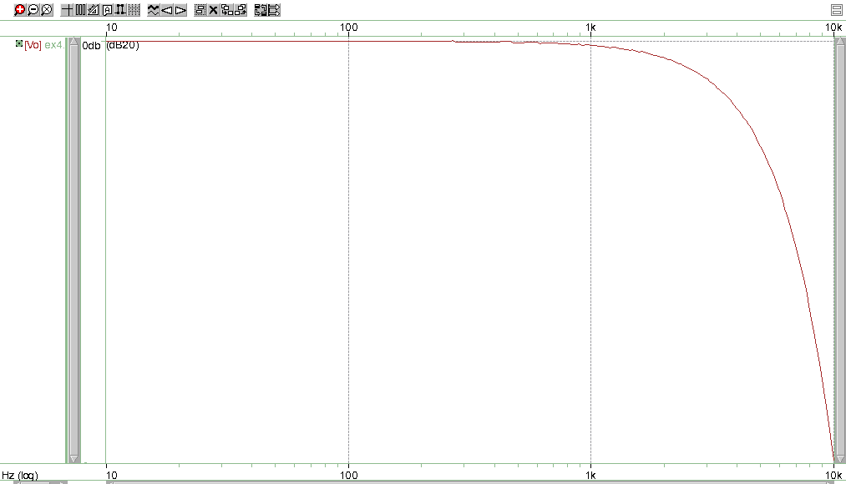

1kΩ and 100 pF from 10Hz-10kHz

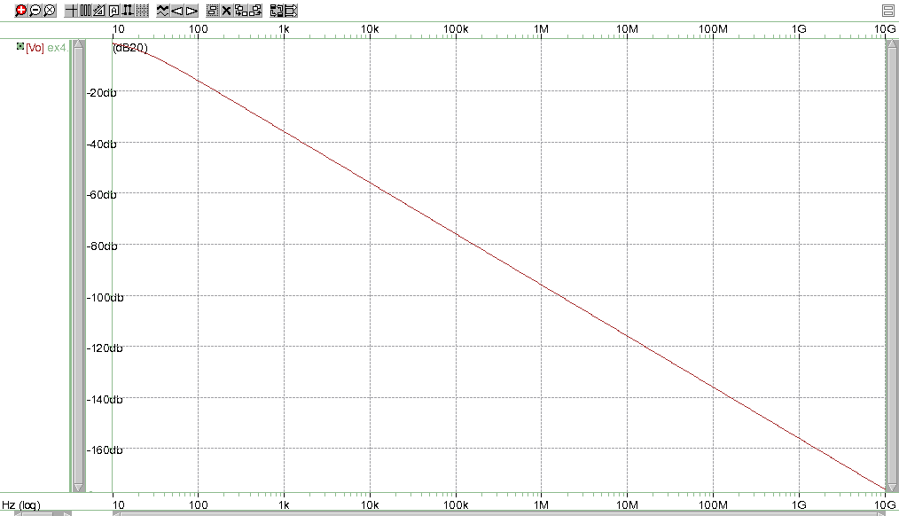

100kΩ and 100 nF from 10Hz-10GHz

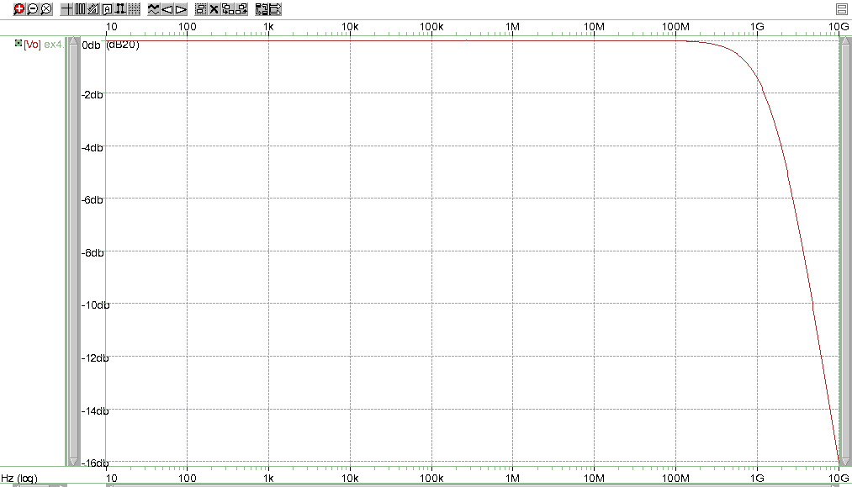

100Ω and 1 pF from 10Hz-10GHz

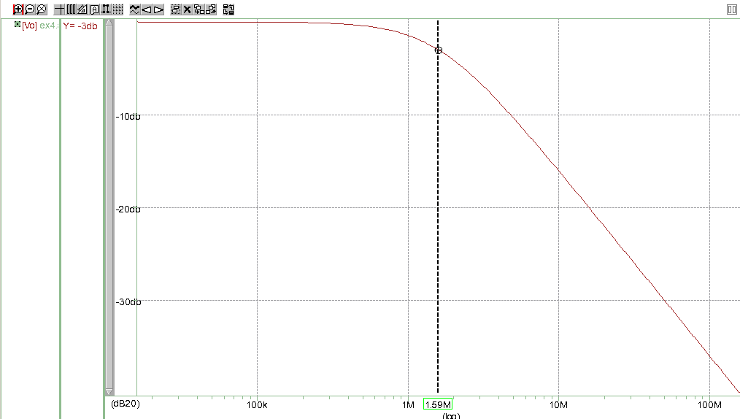

-3 dB frequency

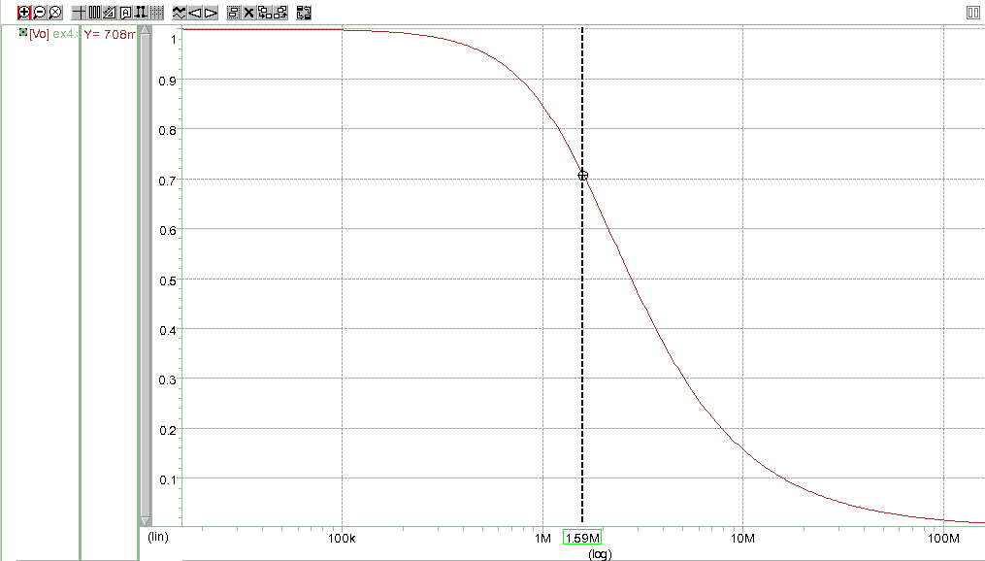

Two decades before and two decades after the -3dB frequency

**Questions**

In the first two graphs, they fail to sweep to show a valid .AC sweep because an educated decision for the frequency range was not done. The problem with the third sweep was that the frequency range is more than what is necessary to find the data needed. According to the hand calculations, the magnitude of the value of Vo at the -3dB frequency is 0.707 V

**Discussion**

The results form the HSpice simulation match with the hand calculations. Therefore, the hand calculations were done correctly. The -3dB frequency is 1.59 MHz and the at the -3dB frequency is 0.707 V.

**Conclusion**

The results clearly agree with the objective of the lab that is to teach students how to use HSpice and WaveView Analyzer. I would like to make a suggestion about the manual attached to the laboratory requirements. I have been investing a lot of my time trying to do Exercise 2. Even after going to office hours, I still do not understand some concepts because we have not covered those topics in class. In addition to not fully understanding the concepts, I do not know the methodology for solving the theoretical questions in Exercise 2. Also, I was not able to solve it because I did not find a similar example in the book or in the internet. The reason I did not finish Exercise 2 is because I do not know how to do it. Even after putting a lot of hours of work into this laboratory and going to office hours, I was lacking information on how to approach the problems. Finally, it would be easier to understand the VCVS example by providing a schematic of the connections.